FEDERAL STATE AUTONOMOUS EDUCATIONAL INSTITUTION OF HIGHER EDUCATION

ITMO UNIVERSITY

Report on the practical task No. 1 “Laboratory work #1.   
Modeling of demographic processes”

Performed by

*Alexander Yamoldin*

*J41321c*

Accepted by Sergei Ivanov

St. Petersburg 2022

Author/group

Yamoldin Alexander Alexeevich / J41321c

Description of the task

* Determine the «survival» rates independently for men and women for all age groups (“0-4” -> “5-9” -> “10-14” ...) according to 2000-2005 years (data for Russia or any other country)
* Determine the fertility rate for women in the age category “20- ... -39”
* Calculate boys/girls ratio for newborn children
* Predict the change in the country's population and demographic profile for 100 years and compare with existing predictions!

Solution methods

I took the data from the <https://population.un.org/wpp/Download/Standard/Population/> . The main idea of this task to predict population according historical data. Russia was my chosen country. The data consist of historical number of people in different age periods for male and female. Example of the data you can see in the picture below:

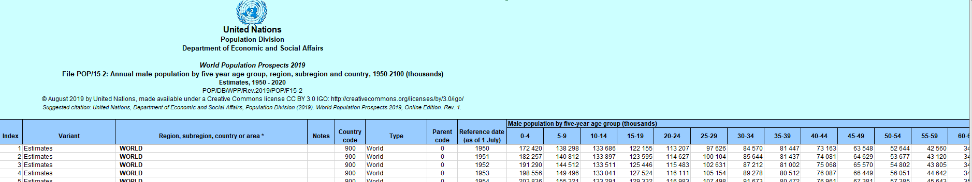

The data were used:





The model is based on the recursive method, which includes the prediction of data based on previous values ​​and the corresponding coefficients.

For a recursive model, we need previous data and corresponding coefficients. As data, we will take, for example, a record of 2020, and the coefficients will be: fertility, the ratio of births of boys to girls, survival rates.

Fertility is found by dividing the total number of births by the number of women aged 15 to 49 in the current period.

The ratio of the birth rate of boys to girls is found by dividing the birth rate of boys by the total birth rate.

Survival rates are found by dividing the previous year's population values ​​by the current population values, with an offset to the next age period.

Finding the found coefficients also partially describes their scope, for example, fertility is used in predicting fertility (that is, a population of ages from 0 to 5 years) by multiplying by the appropriate coefficient of the ratio of boys to girls to separate fertility by sex. Survival rates are applied directly to the values ​​of the previous record, carried over to subsequent ages.

Thus, a recurrent model is obtained that allows predicting future values ​​based on those already determined.

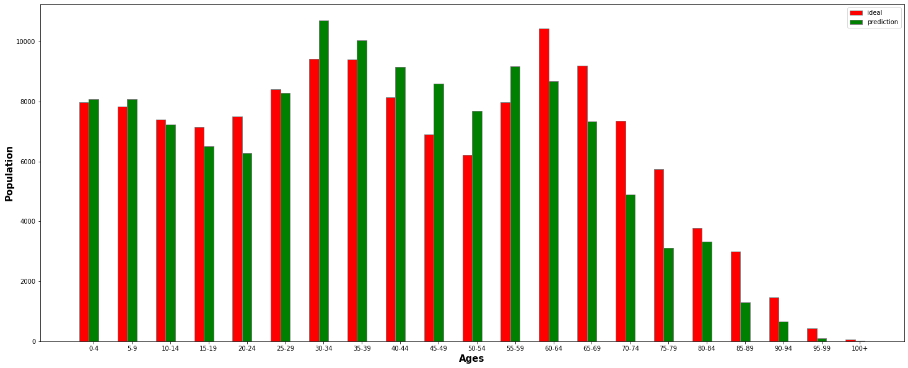Results

Figure1. Comparing original and predicted data (year=2050)

Original picture is 

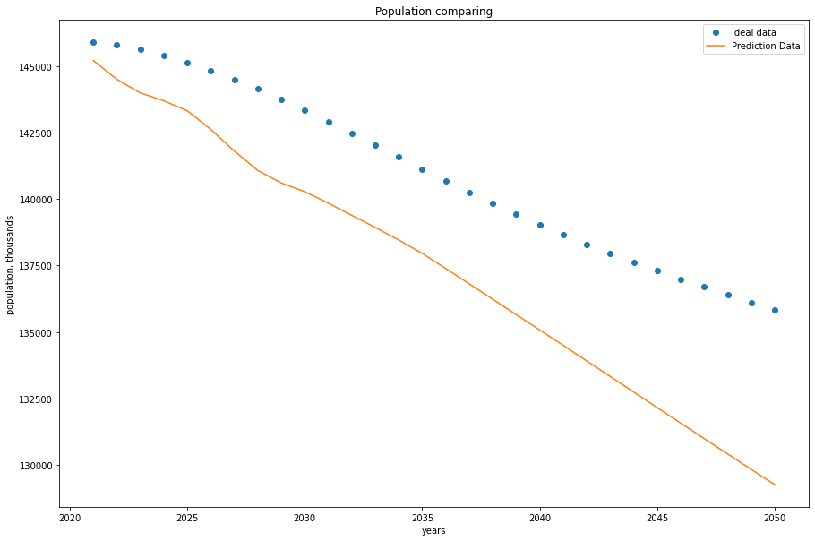

Figure 2. Line chart population comparing

Original picture is 

Conclusion

We modeling a demographic profile for Russian Federation up to 2050 year. We can see that original predicted and our predicted data have **the same trend**. Unfortunately, amount of people in Russia decrease in time so in the future we can face extinction.

Source code can be found here: 